Fraction Determiners

🔹 What Are Fraction Determiners?
# Source: AI Source: Provided by: [Data Path: Persons Table -> ID Column: 1, Name_En Column: Motasem Essam] -> From: [Chatgpt (GPT-4-turbo)] on [7/28/2025]
Fraction Determiners are determiners that indicate a part of a whole — either in quantity, portion, or ratio. They are commonly expressed using fractions like:
- half, one-third, two-thirds, three-quarters, etc.

✅ Function:
# Source: AI Source: Provided by: [Data Path: Persons Table -> ID Column: 1, Name_En Column: Motasem Essam] -> From: [Chatgpt (GPT-4-turbo)] on [7/28/2025]
They act like quantifiers and determiners, modifying a noun by expressing how much or what part of something is referred to.

✅ Examples:
# Source: AI Source: Provided by: [Data Path: Persons Table -> ID Column: 1, Name_En Column: Motasem Essam] -> From: [Chatgpt (GPT-4-turbo)] on [7/28/2025]
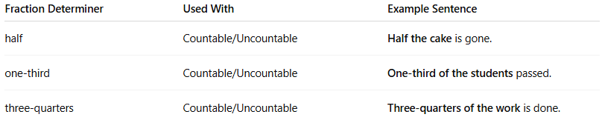

Fraction Determiner | Used With | Example Sentence
half | Countable/Uncountable | Half the cake is gone.
one-third | Countable/Uncountable | One-third of the students passed.
three-quarters | Countable/Uncountable | Three-quarters of the work is done.

🧠 Note:
# Source: AI Source: Provided by: [Data Path: Persons Table -> ID Column: 1, Name_En Column: Motasem Essam] -> From: [Chatgpt (GPT-4-turbo)] on [7/28/2025]
- Fraction determiners are followed by either a noun or a prepositional phrase (e.g., “of the class”).
- They are often quantifiers as well, specifically in the "fraction quantifiers" group.

Summary:
# Source: AI Source: Provided by: [Data Path: Persons Table -> ID Column: 1, Name_En Column: Motasem Essam] -> From: [Chatgpt (GPT-4-turbo)] on [7/28/2025]
🔸 Fraction Determiners express a specific portion of a noun and function both as quantifiers and determiners.
🔸 Common forms: half, one-third, two-fifths, a quarter, etc.

